Watercolor Workshop with Chris Leeper

April 2nd & 3rd 9:00 am - 4:00 pm at Ohio Northern University Art & Design Dept.

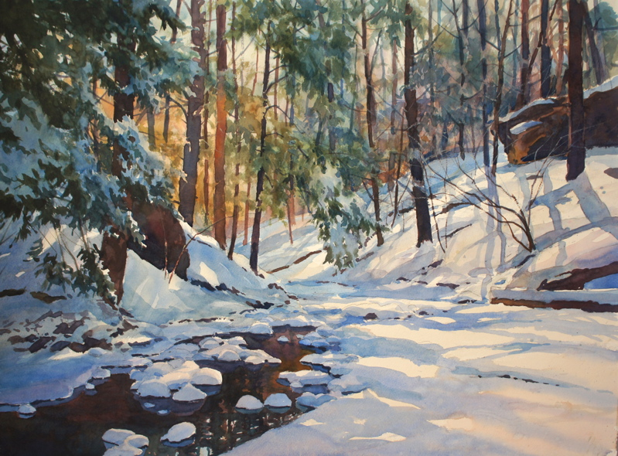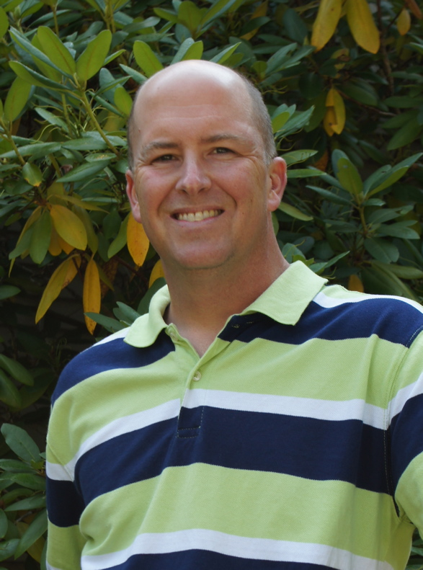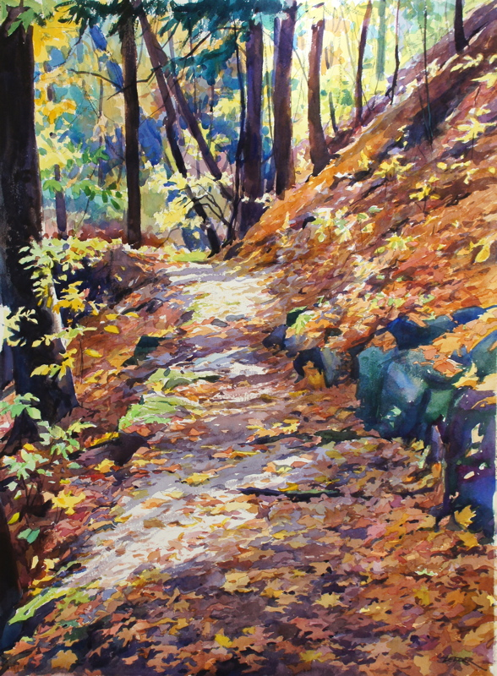

Chris teaches with a fun and relaxed style. Each day there will be demonstrations and lots of one-on-one instruction. This workshop will focus on the process of creating a watercolor painting. He will speak in-depth about devising a plan for success with your painting; the importance of drawing, design and brushwork; simplifying and improving color mixing (no more muddy watercolors) and how to get dynamic value relationships.

Registration Instructions
The fee for this workshop is $25
To register, please send the non-refundable fee, along with the registration form to:
William Mancuso
Ohio Northern University Art & Design Department
525 S. Main St., Ada, OH 45810
Make checks payable to: ONU Art & Design Department
For questions please contact William: (419) 772-2163/2160, w-mancuso@onu.edu

__________________________Please send this section with your deposit______________________

Chris Leeper Workshop: April 2 & 3, 2016 Registration Form

Name ___________________________________________ Address ____________________________________________________

City _____________________________________ State ______________ Zip _________________________

Phone _______________________________________ E-mail _________________________________________________________

